***C code for Merge sort***

***Name: Ishanya***

***Roll no: 21329***

***DSA Assignment***

/* Name: Ishanya

Roll number: 21329

DSA Assignment*/

#include <stdio.h>

#include <stdlib.h>

#include <time.h>

void merge(int arr[], int left, int mid, int right) {

int i, j, k;

int n1 = mid - left + 1;

int n2 = right - mid;

int L[n1], R[n2];

for (i = 0; i < n1; i++)

L[i] = arr[left + i];

for (j = 0; j < n2; j++)

R[j] = arr[mid + 1 + j];

i = 0;

j = 0;

k = left;

while (i < n1 && j < n2) {

if (L[i] <= R[j]) {

arr[k] = L[i];

i++;

}

else {

arr[k] = R[j];

j++;

}

k++;

}

while (i < n1) {

arr[k] = L[i];

i++;

k++;

}

while (j < n2) {

arr[k] = R[j];

j++;

k++;

}

}

void mergeSort(int arr[], int left, int right) {

if (left < right) {

int mid = left + (right - left) / 2;

mergeSort(arr, left, mid);

mergeSort(arr, mid + 1, right);

merge(arr, left, mid, right);

}

}

int main() {

srand(time(NULL));

int arr[1000000];

double totalTime = 0.0;

for (int i = 0; i < 1000000; i++) {

arr[i] = rand();

}

for (int i = 0; i < 100; i++) {

clock_t start_time = clock();

mergeSort(arr, 0, 999999);

clock_t end_time = clock();

double timeTaken = ((double) (end_time - start_time)) / CLOCKS_PER_SEC;

printf("Time taken by Merge Sort on run %d: %f seconds\n", i+1, timeTaken);

totalTime += timeTaken;

}

double avg_time = totalTime / 100;

printf("Total time taken for sorting 100 times: %f seconds\n", totalTime);

printf("Average time taken for sorting 100 times: %f seconds\n", avg_time);

return 0;

}

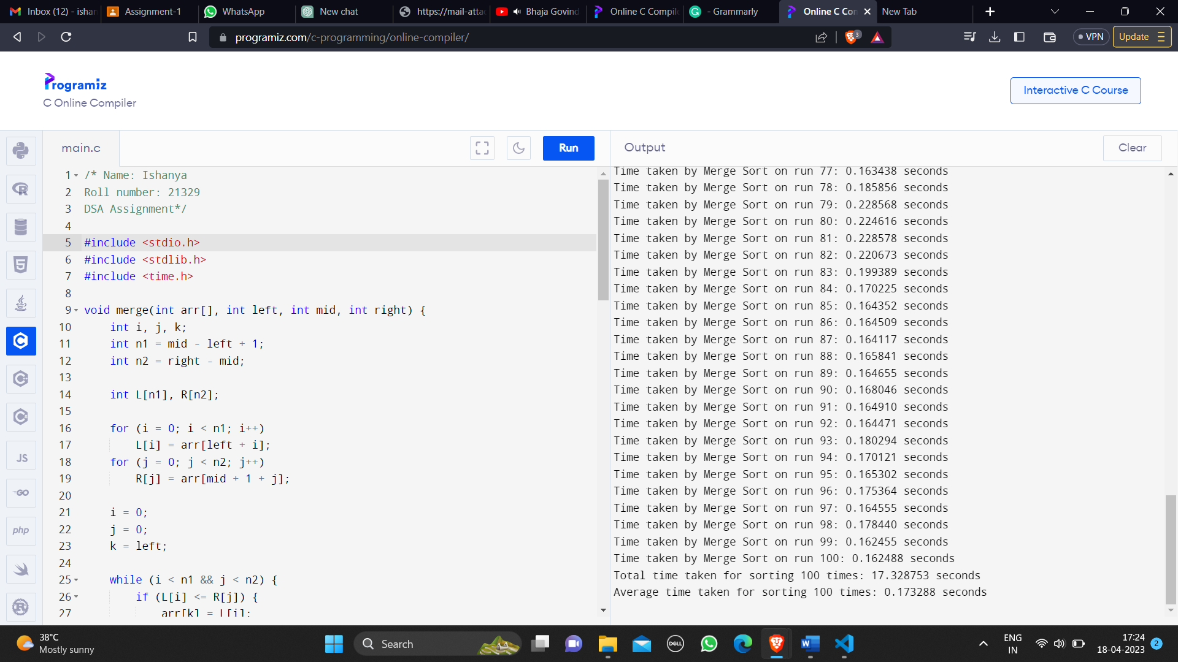

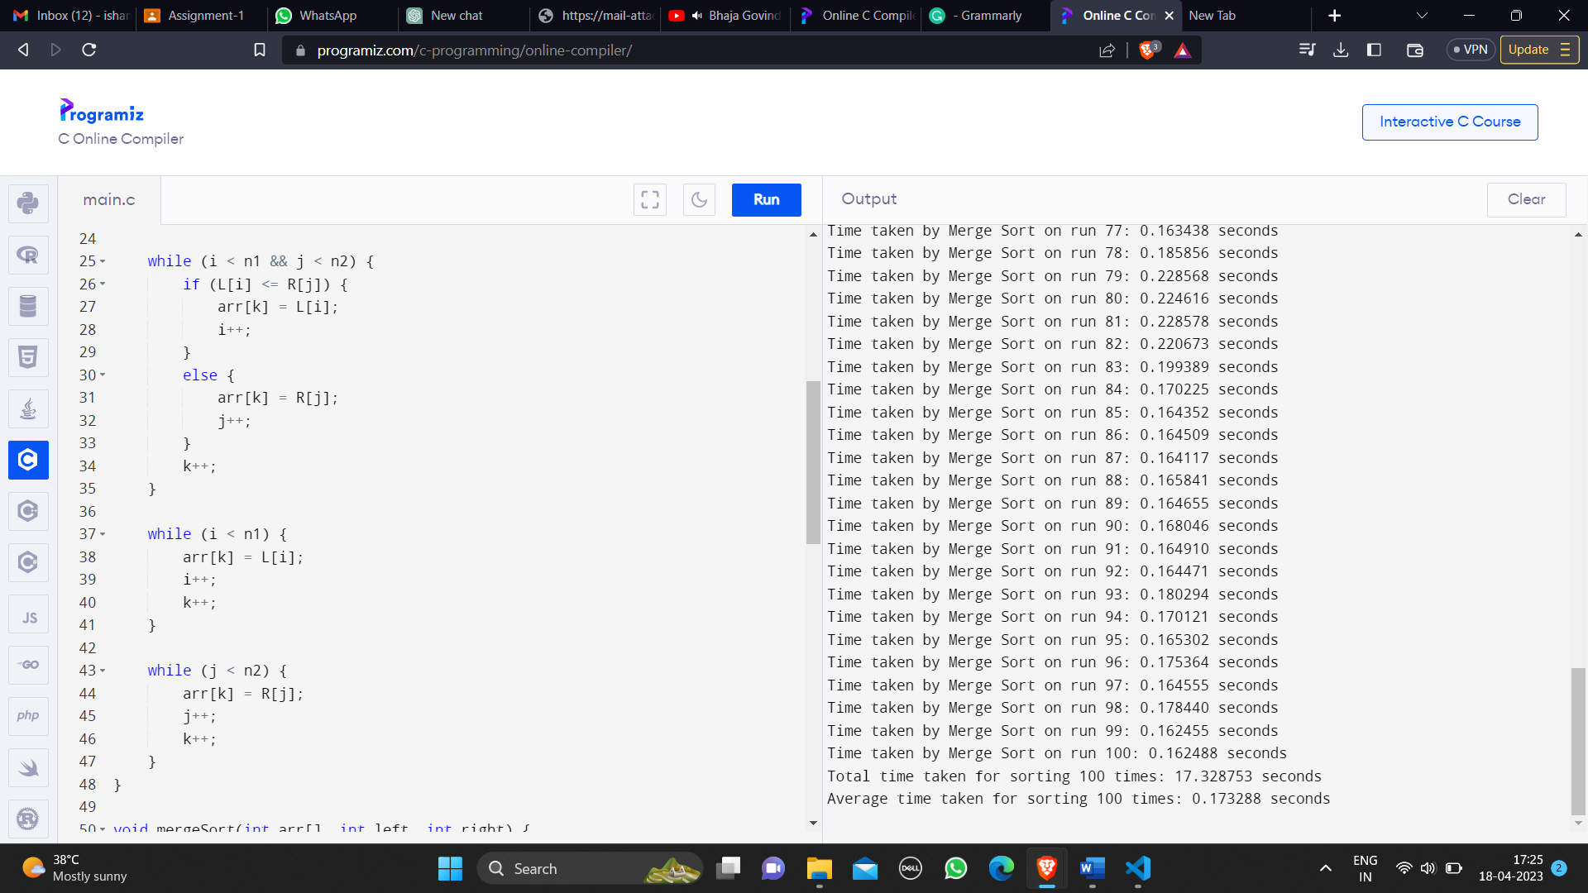

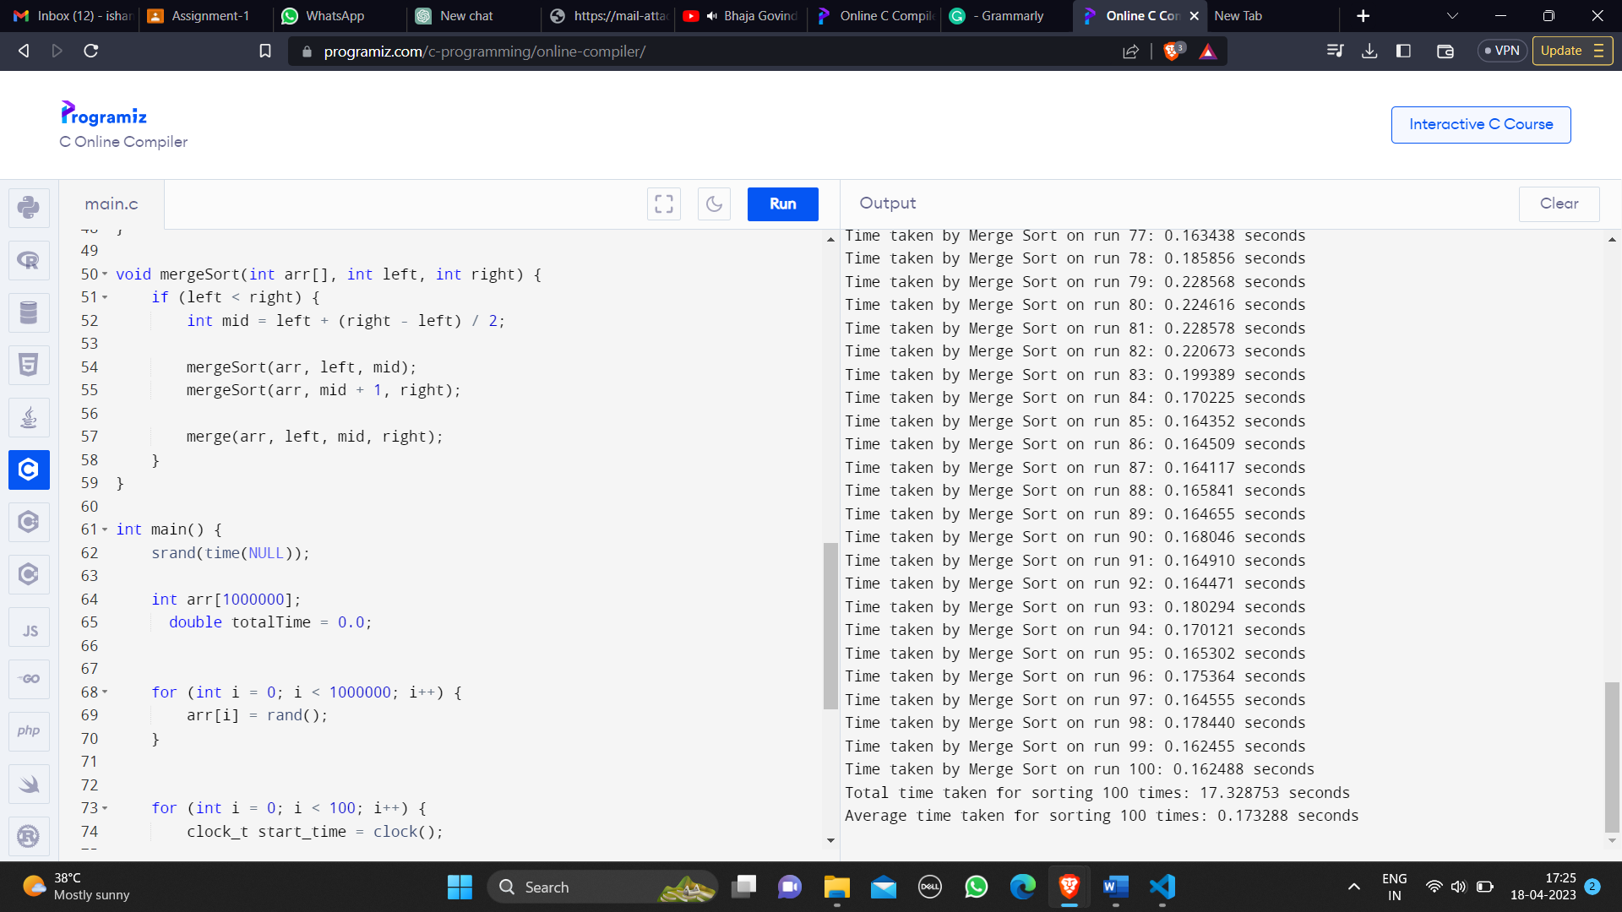

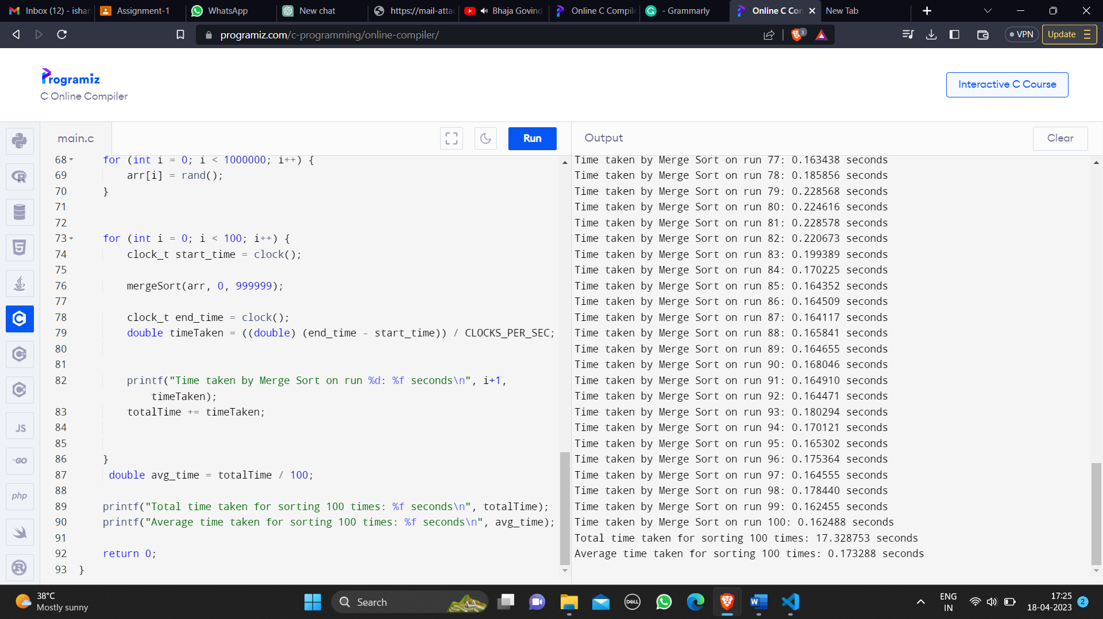

***Report on the CPU time for Merge sort***

Time taken by Merge Sort on run 1: 0.285360 seconds

Time taken by Merge Sort on run 2: 0.165066 seconds

Time taken by Merge Sort on run 3: 0.161872 seconds

Time taken by Merge Sort on run 4: 0.168953 seconds

Time taken by Merge Sort on run 5: 0.177091 seconds

Time taken by Merge Sort on run 6: 0.190248 seconds

Time taken by Merge Sort on run 7: 0.173297 seconds

Time taken by Merge Sort on run 8: 0.172438 seconds

Time taken by Merge Sort on run 9: 0.170908 seconds

Time taken by Merge Sort on run 10: 0.163712 seconds

Time taken by Merge Sort on run 11: 0.167401 seconds

Time taken by Merge Sort on run 12: 0.178961 seconds

Time taken by Merge Sort on run 13: 0.194804 seconds

Time taken by Merge Sort on run 14: 0.171282 seconds

Time taken by Merge Sort on run 15: 0.167425 seconds

Time taken by Merge Sort on run 16: 0.164394 seconds

Time taken by Merge Sort on run 17: 0.167573 seconds

Time taken by Merge Sort on run 18: 0.163613 seconds

Time taken by Merge Sort on run 19: 0.166507 seconds

Time taken by Merge Sort on run 20: 0.169073 seconds

Time taken by Merge Sort on run 21: 0.170983 seconds

Time taken by Merge Sort on run 22: 0.164563 seconds

Time taken by Merge Sort on run 23: 0.166006 seconds

Time taken by Merge Sort on run 24: 0.166506 seconds

Time taken by Merge Sort on run 25: 0.166513 seconds

Time taken by Merge Sort on run 26: 0.171548 seconds

Time taken by Merge Sort on run 27: 0.170993 seconds

Time taken by Merge Sort on run 28: 0.163100 seconds

Time taken by Merge Sort on run 29: 0.164513 seconds

Time taken by Merge Sort on run 30: 0.163757 seconds

Time taken by Merge Sort on run 31: 0.168890 seconds

Time taken by Merge Sort on run 32: 0.174668 seconds

Time taken by Merge Sort on run 33: 0.167321 seconds

Time taken by Merge Sort on run 34: 0.179730 seconds

Time taken by Merge Sort on run 35: 0.170260 seconds

Time taken by Merge Sort on run 36: 0.202715 seconds

Time taken by Merge Sort on run 37: 0.219911 seconds

Time taken by Merge Sort on run 38: 0.170359 seconds

Time taken by Merge Sort on run 39: 0.167762 seconds

Time taken by Merge Sort on run 40: 0.164592 seconds

Time taken by Merge Sort on run 41: 0.164047 seconds

Time taken by Merge Sort on run 42: 0.163485 seconds

Time taken by Merge Sort on run 43: 0.169195 seconds

Time taken by Merge Sort on run 44: 0.180701 seconds

Time taken by Merge Sort on run 45: 0.163226 seconds

Time taken by Merge Sort on run 46: 0.166563 seconds

Time taken by Merge Sort on run 47: 0.170364 seconds

Time taken by Merge Sort on run 48: 0.168417 seconds

Time taken by Merge Sort on run 49: 0.174020 seconds

Time taken by Merge Sort on run 50: 0.165481 seconds

Time taken by Merge Sort on run 51: 0.166266 seconds

Time taken by Merge Sort on run 52: 0.165396 seconds

Time taken by Merge Sort on run 53: 0.166048 seconds

Time taken by Merge Sort on run 54: 0.162301 seconds

Time taken by Merge Sort on run 55: 0.171350 seconds

Time taken by Merge Sort on run 56: 0.164662 seconds

Time taken by Merge Sort on run 57: 0.165173 seconds

Time taken by Merge Sort on run 58: 0.168856 seconds

Time taken by Merge Sort on run 59: 0.165834 seconds

Time taken by Merge Sort on run 60: 0.169607 seconds

Time taken by Merge Sort on run 61: 0.166100 seconds

Time taken by Merge Sort on run 62: 0.164330 seconds

Time taken by Merge Sort on run 63: 0.164994 seconds

Time taken by Merge Sort on run 64: 0.177234 seconds

Time taken by Merge Sort on run 65: 0.164042 seconds

Time taken by Merge Sort on run 66: 0.167561 seconds

Time taken by Merge Sort on run 67: 0.167784 seconds

Time taken by Merge Sort on run 68: 0.167004 seconds

Time taken by Merge Sort on run 69: 0.165821 seconds

Time taken by Merge Sort on run 70: 0.164146 seconds

Time taken by Merge Sort on run 71: 0.166885 seconds

Time taken by Merge Sort on run 72: 0.175873 seconds

Time taken by Merge Sort on run 73: 0.174229 seconds

Time taken by Merge Sort on run 74: 0.164116 seconds

Time taken by Merge Sort on run 75: 0.165260 seconds

Time taken by Merge Sort on run 76: 0.166451 seconds

Time taken by Merge Sort on run 77: 0.163438 seconds

Time taken by Merge Sort on run 78: 0.185856 seconds

Time taken by Merge Sort on run 79: 0.228568 seconds

Time taken by Merge Sort on run 80: 0.224616 seconds

Time taken by Merge Sort on run 81: 0.228578 seconds

Time taken by Merge Sort on run 82: 0.220673 seconds

Time taken by Merge Sort on run 83: 0.199389 seconds

Time taken by Merge Sort on run 84: 0.170225 seconds

Time taken by Merge Sort on run 85: 0.164352 seconds

Time taken by Merge Sort on run 86: 0.164509 seconds

Time taken by Merge Sort on run 87: 0.164117 seconds

Time taken by Merge Sort on run 88: 0.165841 seconds

Time taken by Merge Sort on run 89: 0.164655 seconds

Time taken by Merge Sort on run 90: 0.168046 seconds

Time taken by Merge Sort on run 91: 0.164910 seconds

Time taken by Merge Sort on run 92: 0.164471 seconds

Time taken by Merge Sort on run 93: 0.180294 seconds

Time taken by Merge Sort on run 94: 0.170121 seconds

Time taken by Merge Sort on run 95: 0.165302 seconds

Time taken by Merge Sort on run 96: 0.175364 seconds

Time taken by Merge Sort on run 97: 0.164555 seconds

Time taken by Merge Sort on run 98: 0.178440 seconds

Time taken by Merge Sort on run 99: 0.162455 seconds

Time taken by Merge Sort on run 100: 0.162488 seconds

***Total time taken for sorting 100 times: 17.328753 seconds***

***Average time taken for sorting 100 times: 0.173288 seconds***